AN AWARD WINNER INTERNATIONAL ORGANIZATION
a Im
PROMOTING EXCELLENCE IN DENTAL EDUCATION
Over 7000 Members Strong
Presents
A Must attend seminar for you and your staff
ENDODONTICS FOR GENERAL DENTIST
BY
DR CHRISTOPHER COOK
ONLINE WEBINAR

On
MAY19TH, 2024 (Sunday) 8:00 am till 12:00 NOON
(CA Board 4 hrs C.E. units)
at

(Please print in capital letters or attach your business card)
Name DR/RDH/RDA/DA Lic no
Circle one First Middle Initial Last
Address
City State Zip
Cell no ______________ Accept text message yes/no E-Mail________________________________________
ARE YOU A PDS MEMBER: YES/ NO

REGISTRATION FEE
Dentists Non-members | $50.00
Members | $40.00
Hygienist/R.D.A. Non-members | $40.00
Members | $35.00
FOR REGISTRATION
CALL TOLL FREE 1-866-422-5573 (1-866-4-CALL-PDS) OR 909-933-9076
TO REGISTER ONLINE VISIT US ON WWW PDSOCIETY. COM

Make check payable to

Dr. R. Salwan
President
PDS
124 EAST F STREET SUITE #8 ONTARIO, CA 91764
Dr. D.P. Singh Nagra
Chairman

Webinar Date & Time:
Sunday, Feb 19th, 2024, 8:00 AM - 12.00 PM Pacific Time (US & Canada)
Duration: 4 Hours

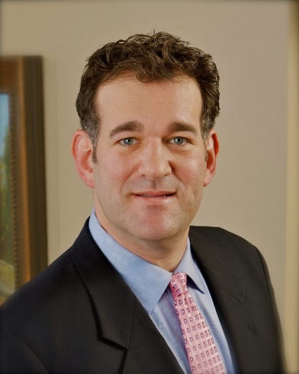
Christopher Cook, DMD is a native of Fort Thomas, Kentucky. He graduated from the University of Louisville School of Dentistry as a Doctor of Medicine Dentistry (DMD) in 1995. After graduation, Dr. Cook served six years as an officer in the US Navy as a general dentist, where he attained the rank of Lieutenant Commander. He served our country in North America and Europe. Dr. Cook also had the privilege to work with the Surgeon General of the Navy in Washington, DC. He received his specialty training at the University of Louisville Graduate Endodontic Program.
In 2003, Dr. Cook opened Hillside Endodontics in Floyds Knobs, Indiana. He built a successful practice and then decided to relocate to Louisville to be near his growing family.
Dr. Cook is a member of the American Association of Endodontics (AAE), the American Dental Association (ADA), the Kentucky Dental Association (KDA), the Louisville Dental Association (LDA) and the past president of the Southern Indiana Dental Association (SIDA).
During the past 20 years, Dr. Cook has lectured across the country and conducted numerous continuing education courses in Endodontics. He also taught Endodontics to dental and postgraduate students at the University of Louisville School of Dentistry.
His other interests include hunting, fishing, scuba diving and travel.

Introduction To Procedural Endodontic Techniques
Learn from Dr. Chris Cook about next-generation endodontic techniques and technologies.
Earn 4 CE at this evidence-based hands-on course and you will:
- Learn about procedural endo techniques from start to finish
- Discover new technology that has the potential to make endodontics safer and more effective
- Review modern obturation techniques and case studies using bioceramic sealer
During the event, you will also get the opportunity to test out Komet's new EndoPilot, a torque and speed controlled endodontic motor that can determine the real-time file position during treatment, and get an introduction to Komet's new endo line.

THIS EVENT IS SPONSORED BY PDS AND Komet USA

